30 - The Cars – Just What I Needed
This is in D. Original in same key.
KORG switch: SINE, 8VES YAM switch: WURLI, WINT

[Intro] 8 meas E
(quarter or eight note accents on last beat)
[Verses]
E | B | c#m | G# [3x] | Verse 1: just clicks  Go to instrumental  Verse 2: chords stabs on beat 1  melody added 3rd & 4th  Go to Chorus, then Solo  Verse 3: repeat verse 2  Go to Chorus, play twice  Outro Chorus with new melody
E | B | G# | A [1x]

[Instrumental with synth melody]
E | B | c#m | G# [1x]
E | B | c#m | A [1x]

[Chorus]
E B | A C# B | E B | A C# [2x]

[Guitar Solo] Chord support for Paul
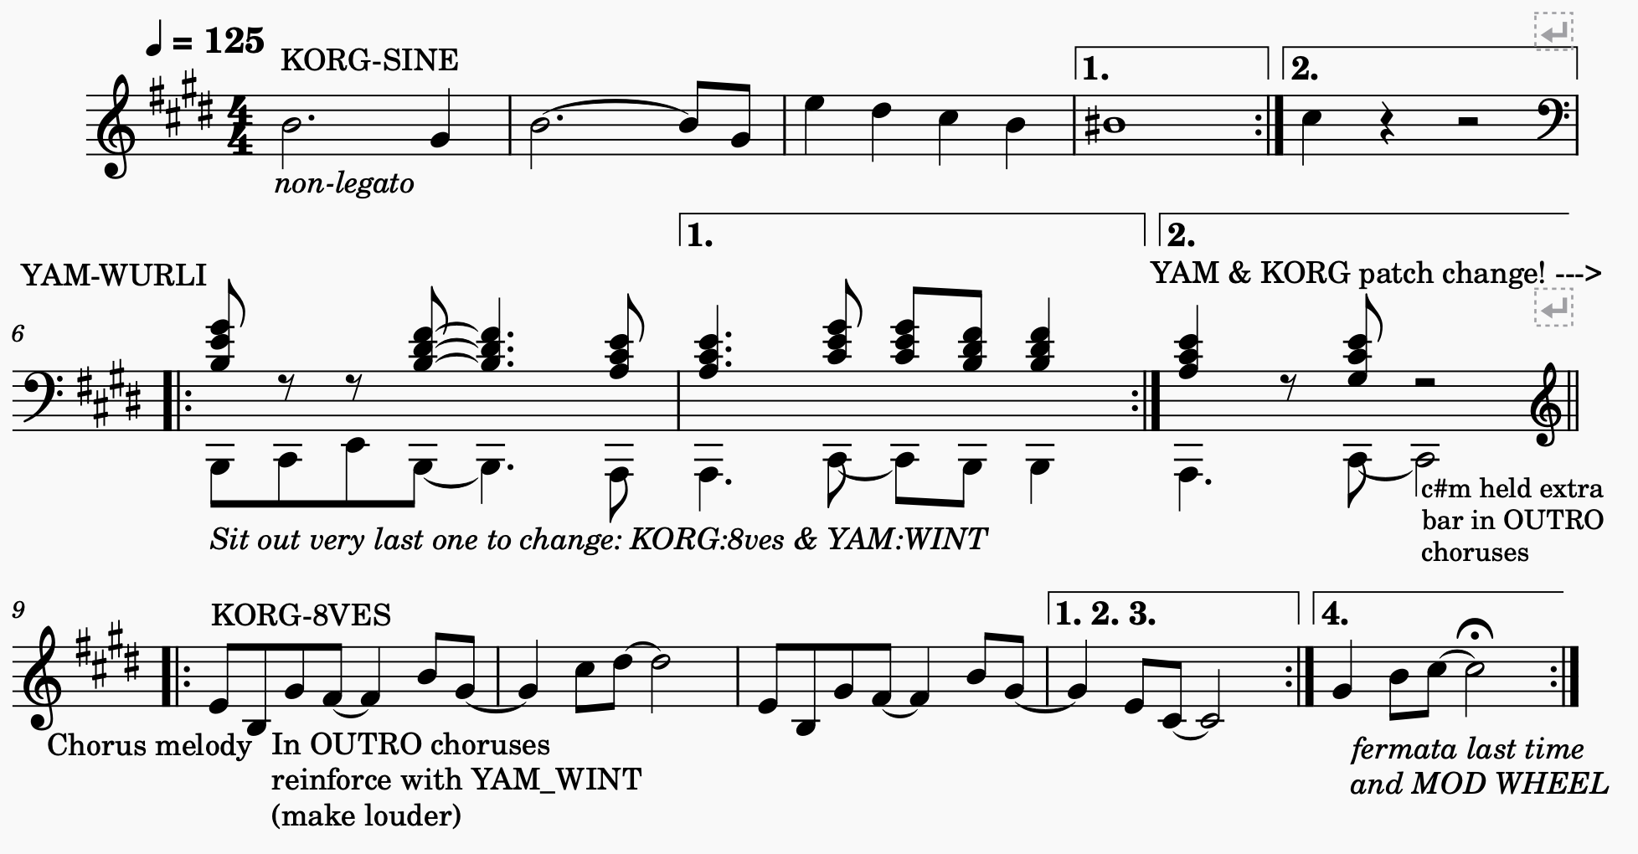
E B | c#m G# | E B | c#m A [2x]

